ArchestrA Script Creator User Manual

October 2014

# Usage

The ArchestrA Script Creator is used to create a long ArchestrA script given a text file containing field attributes. The script that is created is a script that is used by me to create relative referencing tag names based on the reference list in a DI Object. See the “Example aaCreateScript Field Attributes.txt” file and the “Example aaCreateScript Script.txt” file for a better understanding. You give the Field Attributes text file, you run the script and you get the script file.

# Prerequisites

The script is written in Python version 3.4. Python 3.4 is an easy to use programming language that is available free to download and easy to install and work with. You will need the following:

1. Python 3.4 installed on your PC
2. Python added to your path
3. The aaCSV.py script
4. The exported CSV file for your object

# Example

## Run the program

Open up the command prompt and change the directory to the path where your aaCreateScript.py file resides.

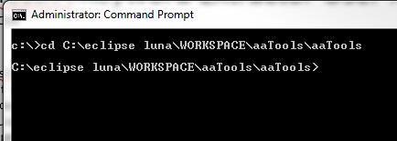

Figure 1.

Type in the program name followed by the input text file (containing the field attributes) followed by the new file name you want the script to be in. See figure 2.

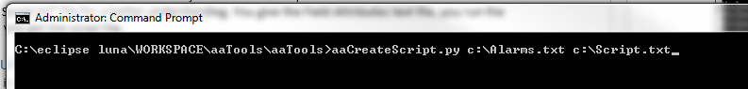

Figure 2.

Press enter and your file will be created.

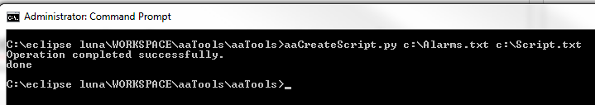

Figure 3.

The typical input file had 87 Field Attributes that looked something like these 5 Field Attributes

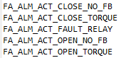

Figure 4.

The newly created script text file contents will look something like this, for each of the 87 Field Attributes:

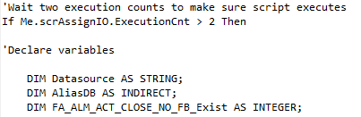

Figure 5. Declaration part.

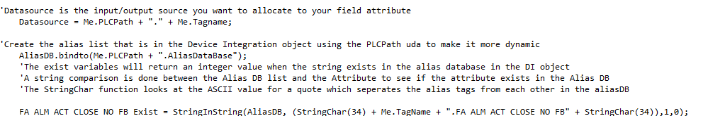

Figure 6. See if reference exists in the DI Object

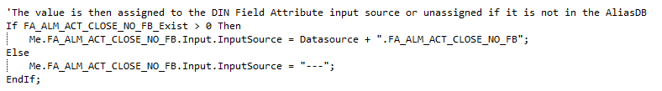

Figure 7. Assigning the reference tag name if it exists.

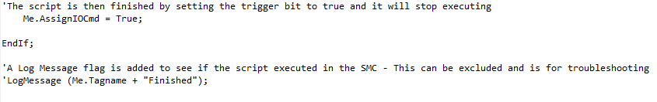

Figure 8. End of the script.

That is it. Saved a lot of typing and copying and pasting. Now you can copy and paste this script into your ArchestrA script.

See the two example text files for better understanding of what this script does. You can modify and adapt the script to your scripts.

End.